**Title: Power BI Setup and Usage Guide**

**Introduction to Power BI**

Power BI is a complete reporting solution that offers data preparation, data visualization, distribution, and management through development tools and an online platform. Power BI can scale from simple reports using a single data source to reports requiring complex data modeling and consistent themes. Use Power BI to create visually stunning, interactive reports to serve as the analytics and decision engine behind group projects, divisions, or entire organizations.

**Key Features and Benefits :**

* User-Friendly Interface
* Wide Range of Data Connectivity
* Advanced Data Visualization
* Real-Time Data Updates
* Strong Data Transformation Capabilities

**Power BI Components (Desktop, Service, Mobile)**

* Connect to data with Power BI Desktop.
* Transform and model data with Power BI Desktop.
* Create visualizations and reports with Power BI Desktop.
* Publish report to Power BI service.
* Distribute and manage reports in the Power BI service.

**2. How to Set Up Power BI**

**Step 1:** Download Power BI Desktop from the official website

**Step 2:** Install Power BI Desktop (Walkthrough with Screenshots)

**Step 3:** Initial Setup and First-Time Configuration

**Step 4:** Understanding the Power BI Interface

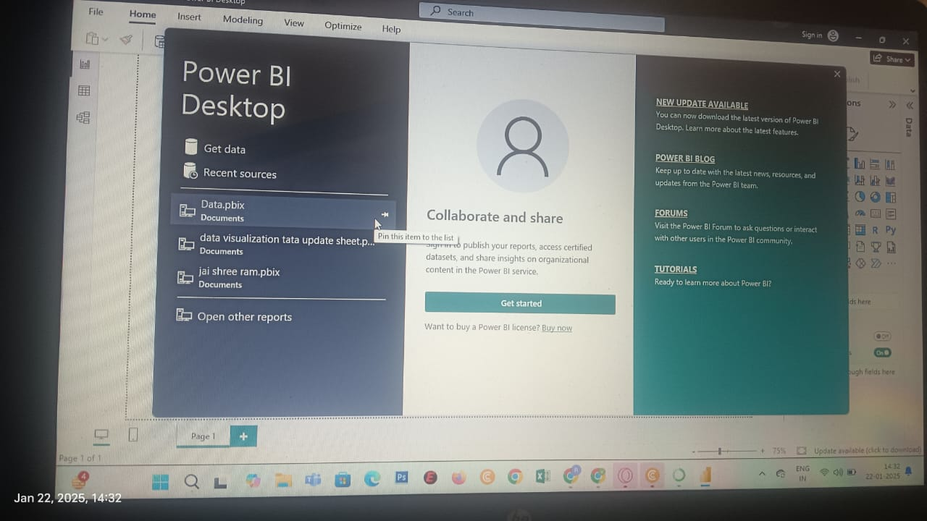

**3. How to Get Data in Power BI**

**Step 1:** Connecting to Different Data Sources

(Excel, SQL Server, Web Data, CSV Files) 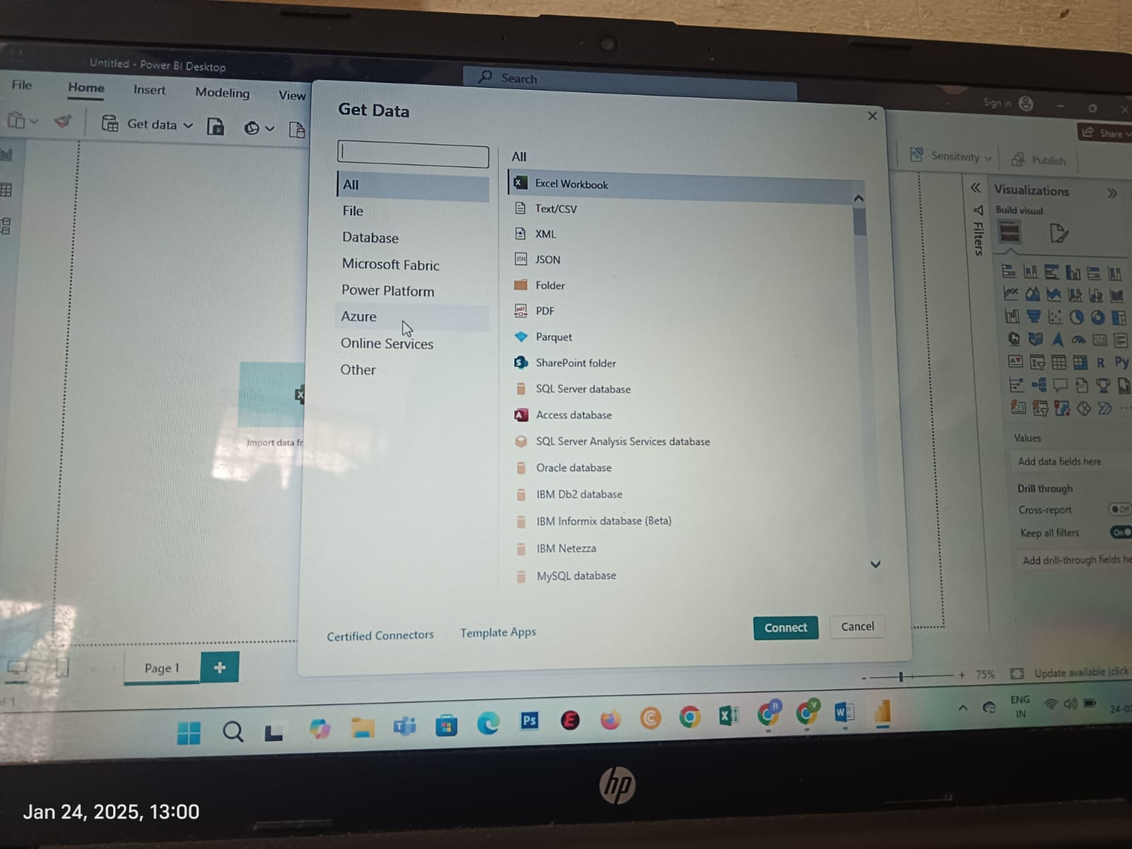

**Step 2:** Importing Data into Power BI

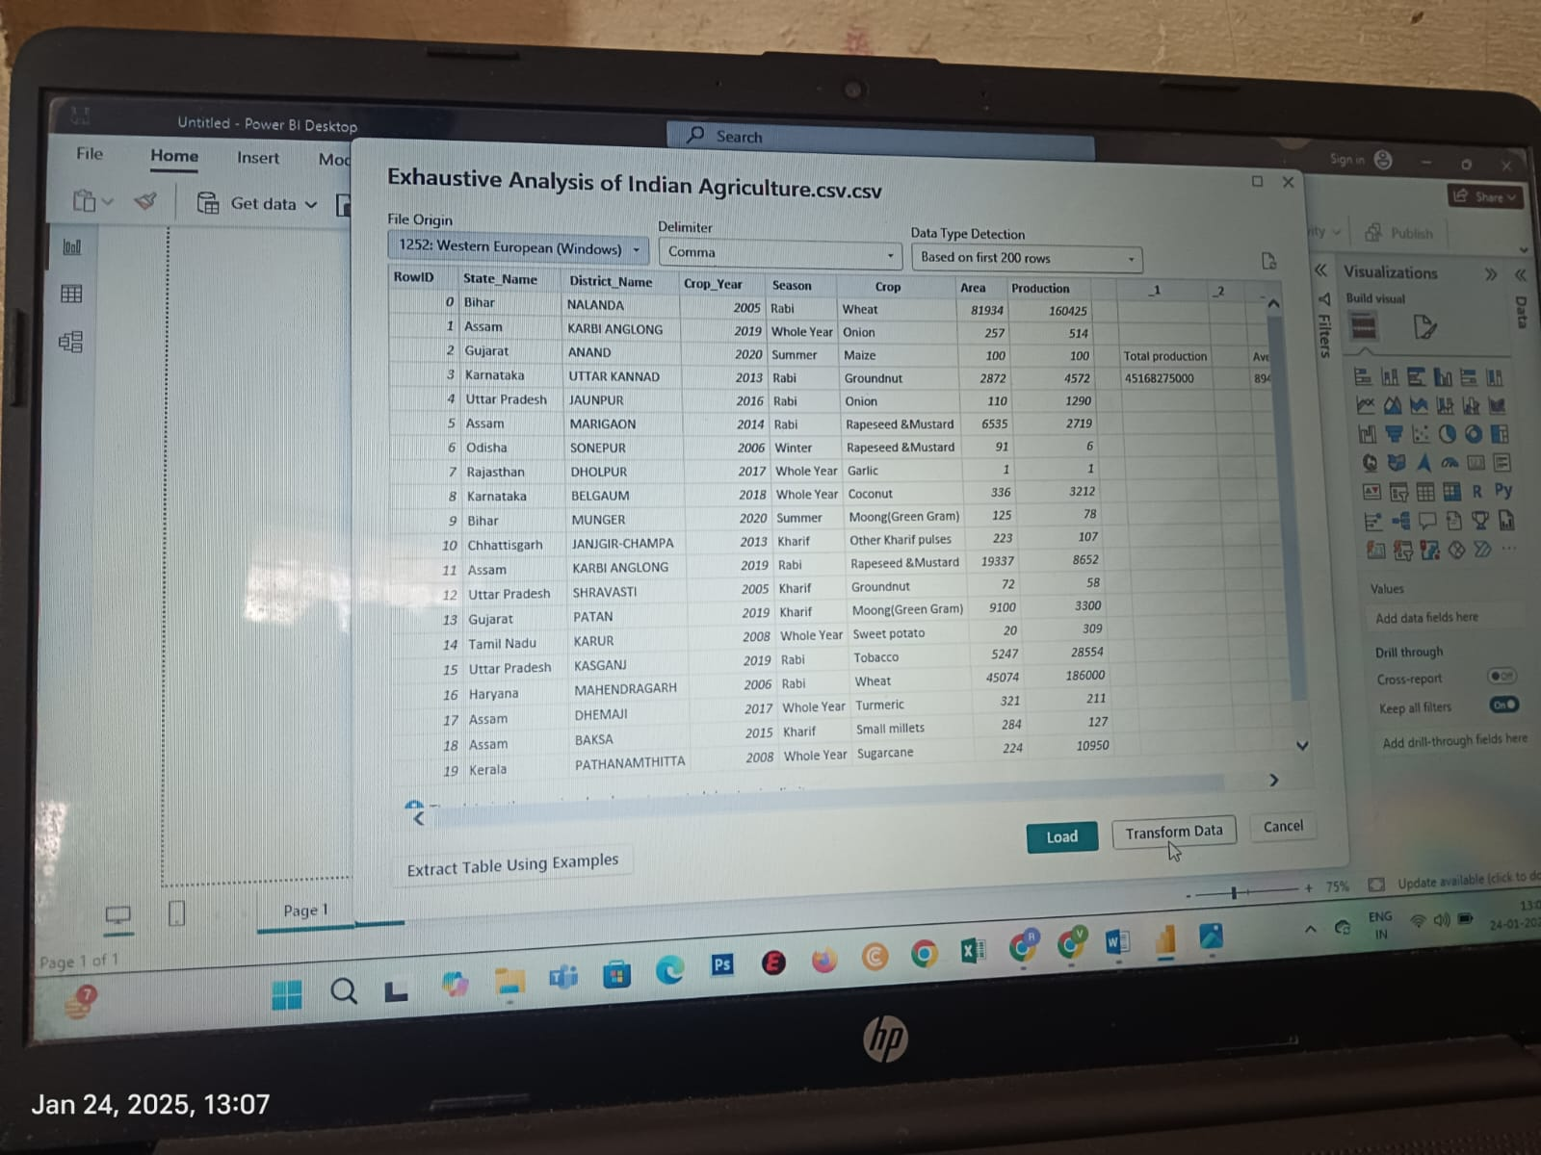

**Step 3:** Data Loading vs Direct Query Mode

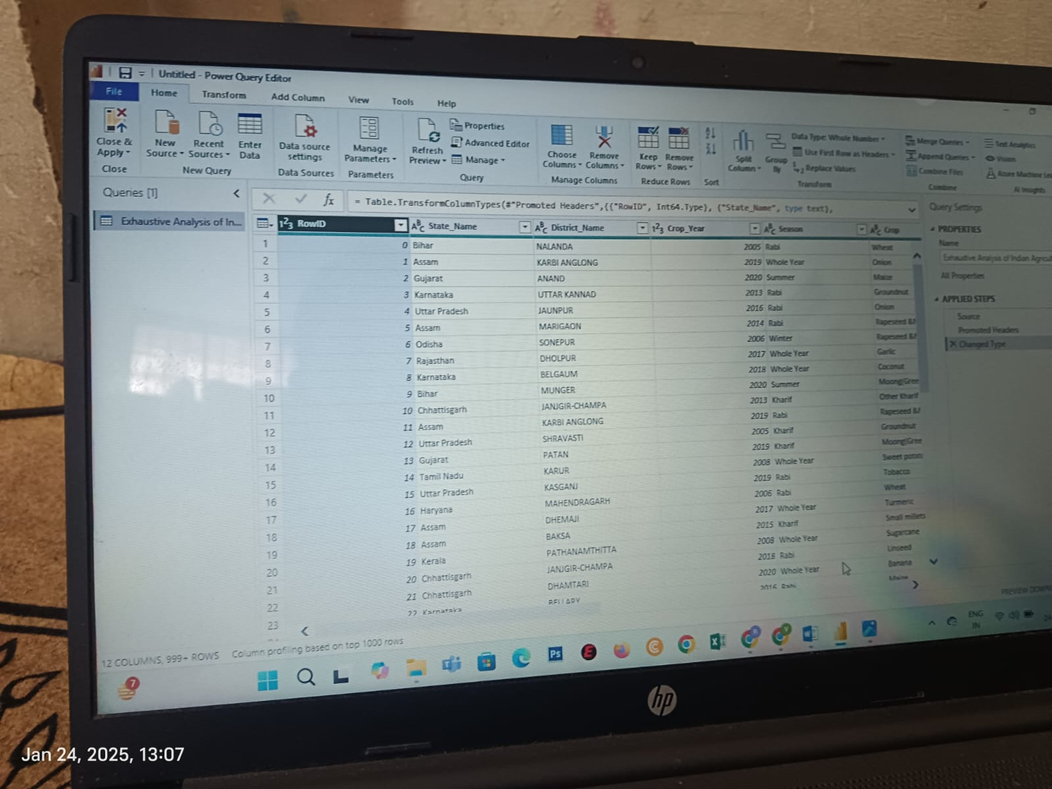

**Step 4:** Managing Data Refresh



**4. How to Transform Data in Power BI**

* Using Power Query Editor



* Removing Duplicates

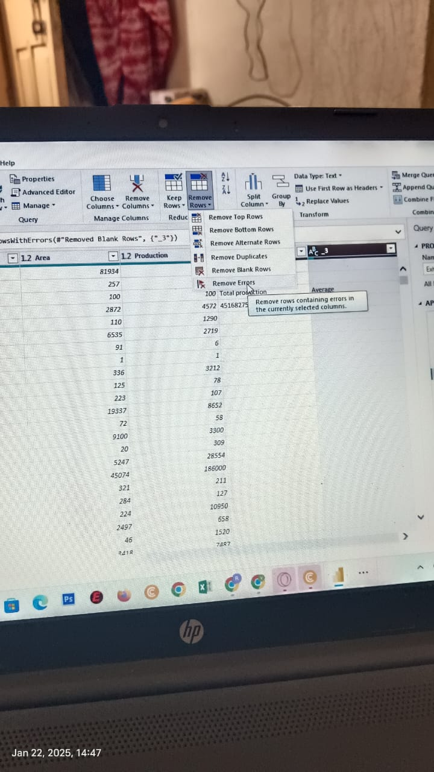

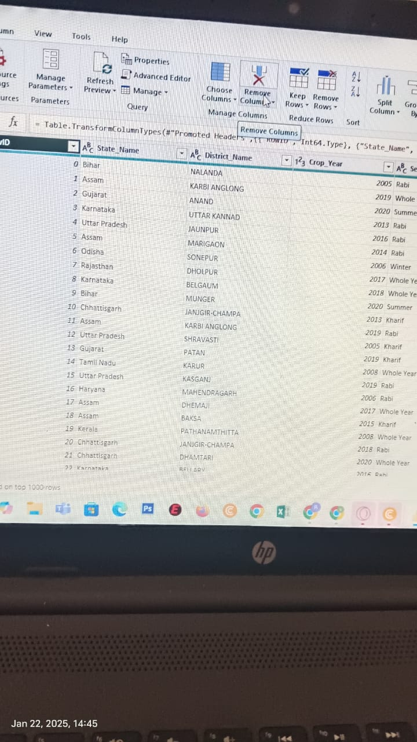

* Handling Null Values

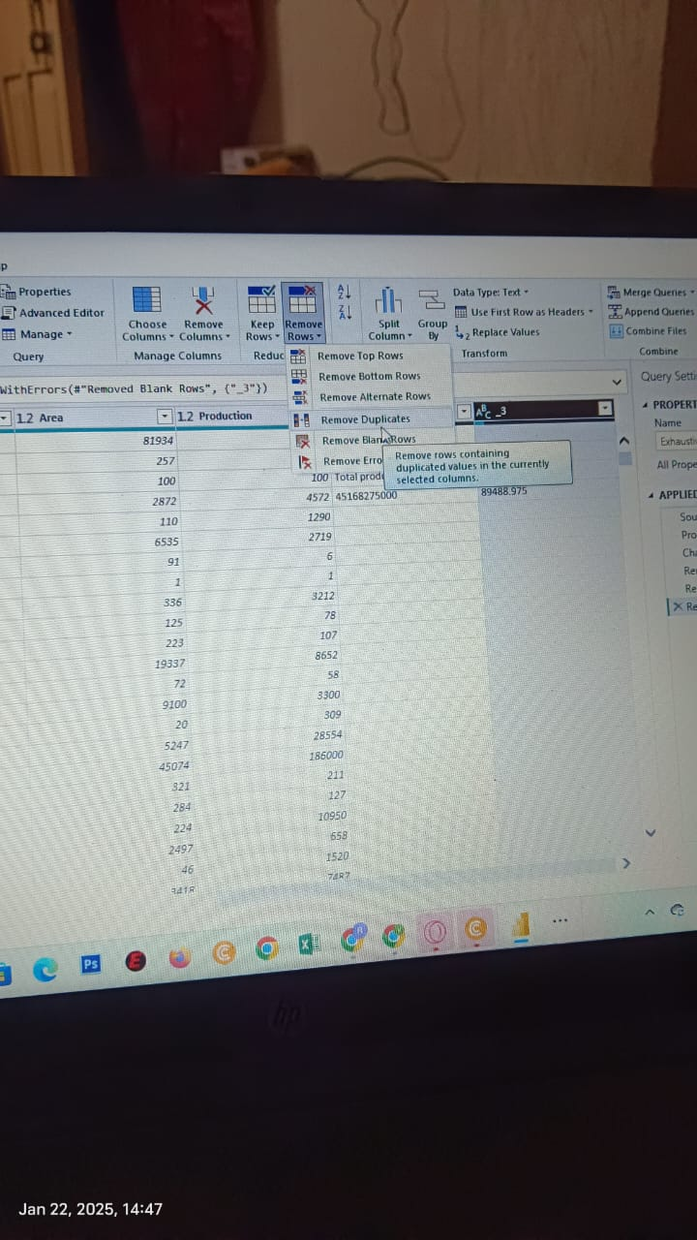

* Splitting Columns
* Data Type Conversion
* Merging Queries
* Using DAX (Data Analysis Expressions) for Transformations
* Best Practices for Data Cleaning and Transformation

**5. How to Perform Data Visualization in Power BI**

**Step 1:** Selecting the Right Visualization Type (Bar, Pie, Line, etc.)

**Step 2:** Dragging Fields to the Visualization Pane

**Step 3:** Formatting Visuals (Titles, Colors, Legends)

**Step 4:** Adding Filters and Slicers for Dynamic Data Interaction

**Step 5:** Creating Interactive Dashboards with Multiple Visuals

**Step 6:** Using Drill-Down and Drill-Through Features

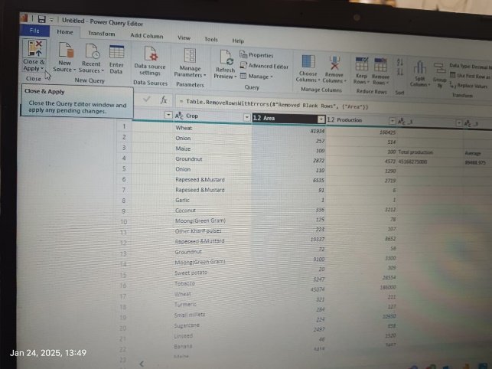

**6. How to View Reports in Power BI**

**Step 1:** Viewing Reports in Power BI Desktop

**Step 2:** Publishing Reports to Power BI Service

**Step 3:** Sharing Reports with Others via Links

**Step 4:** Accessing Reports on Power BI Mobile App

**Step 5:** Exporting Reports as PDFs or PowerPoint Presentations